2b-1 Cloud Web Server Deployment with Amazon EC2

Class Activity Overview
This lab introduces students to cloud-based server deployment using Amazon EC2. Students will configure a virtual machine, install Apache web server, serve files online, and understand basic budgeting and cost management in cloud environments.

Learning Objectives
- - Launch and configure a Linux VM instance using EC2 or other cloud providers.
- - Secure SSH access using key pairs.
- - Install and configure Apache web server.
- - Serve web content from the cloud instance.
- - Transfer files and modify HTML content.
- - Understand budgeting and cost monitoring in AWS.
- - Complete cloud-based troubleshooting and testing.

Lab Setup and Execution
- - Log in to AWS EC2 Console and create a new Ubuntu 20.04 instance (free tier eligible).
- - Name the security group 'ssh-and-web' and allow both SSH and HTTP traffic.
- - Download key pair and save safely. Use this for SSH login via terminal.
- - Connect to the VM using provided SSH command (`ssh -i key.pem ubuntu@IP`).
- 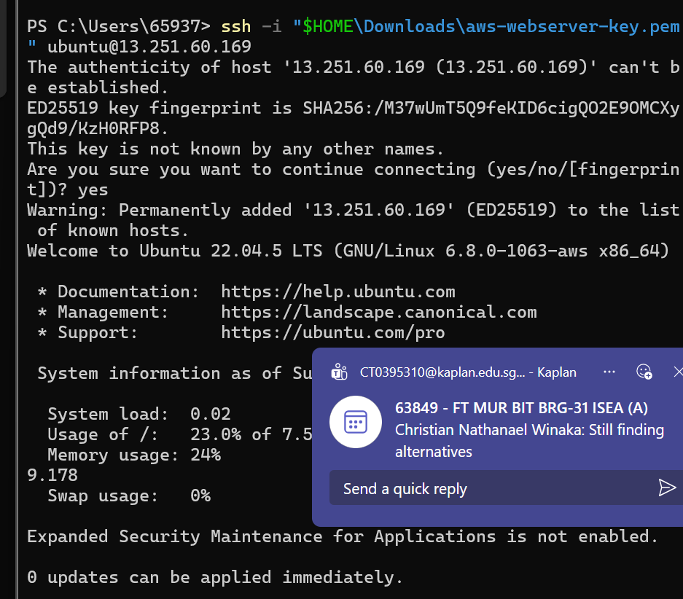
- - Run `sudo apt update` and install Apache using `sudo apt install apache2`.
- 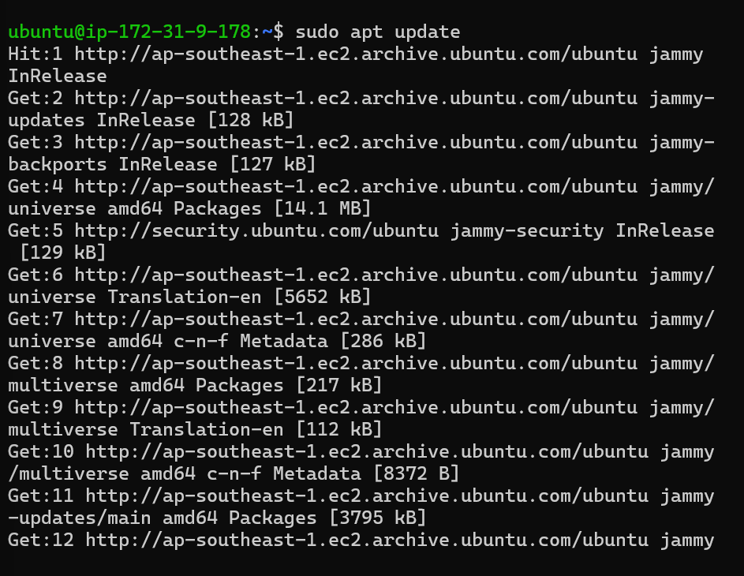
- 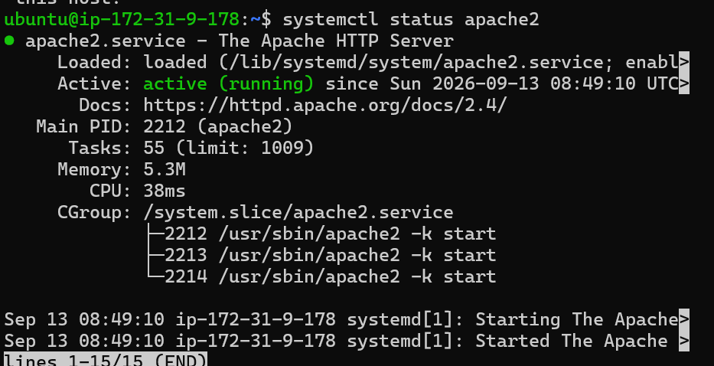-
- Access the server using its public IP in a browser (via HTTP).
- 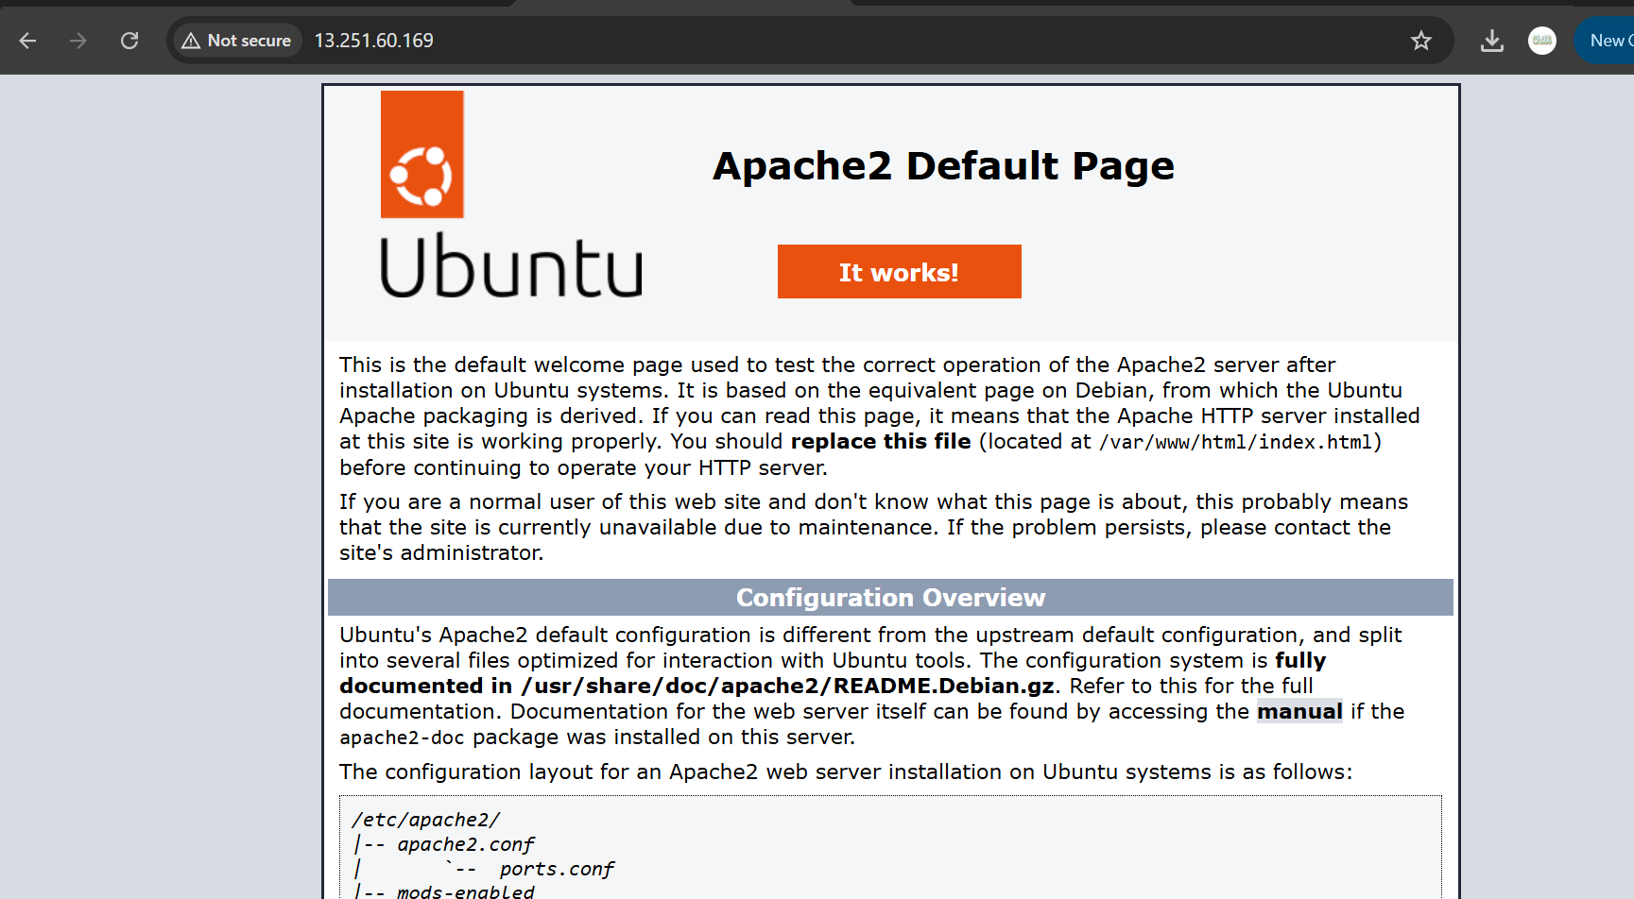
- - Modify `/var/www/html/index.html` using nano and test the changes live.
- 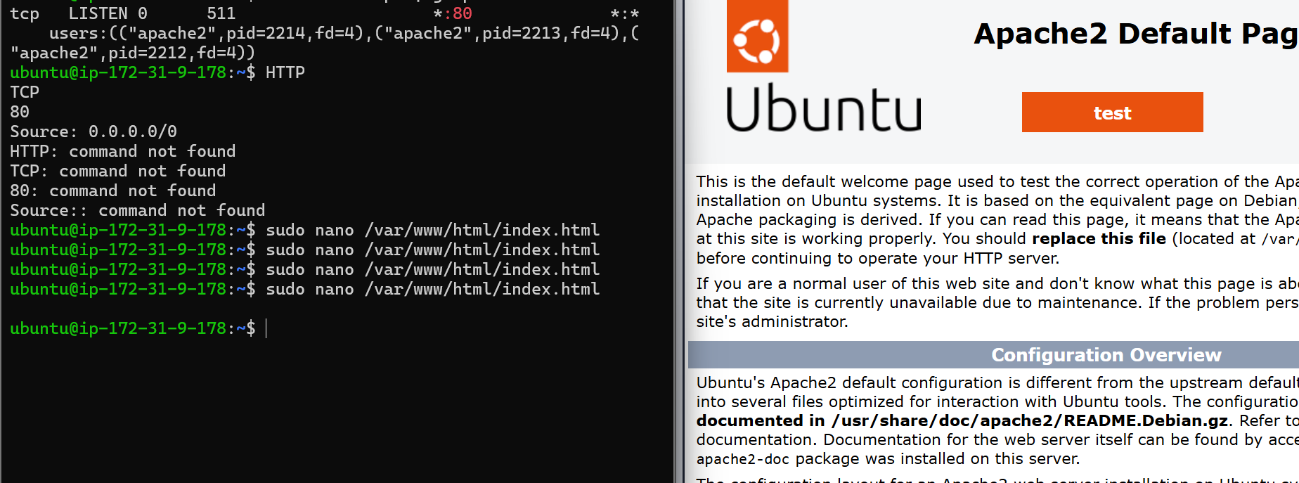
- - Download and copy files to `/var/www/html/` using `wget` and `sudo cp`.
- 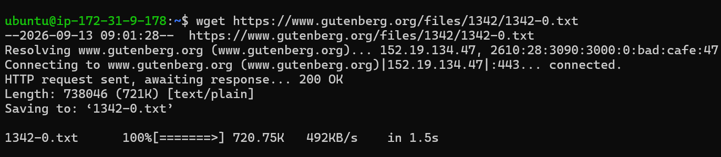
- - Create hyperlinks in `index.html` using anchor `<a>` tags.
- - Test access using different devices and browsers.

File Transfer & Permissions
- - Use `wget` to download remote files to your VM.
- - Use `sudo cp` to move them into the web directory.
- - Use `scp -i key.pem localfile ubuntu@IP:/home/ubuntu/` to copy files from local to VM.
- - Use `chmod` or change ownership if facing file access issues.

Budget and Cost Monitoring in AWS
- - Log into AWS Billing Dashboard via EC2 console.
- - Set up a budget alert to avoid unexpected charges.
- - Review instance charges and terminate unused resources.
- - Avoid launching high-tier or GPU-backed instances.

Optional Challenges

Challenge 1: Network Latency Testing
- - Use `ping` to test servers in different countries.
- - Compare latencies and discuss expected vs observed results.
- - Discuss alternatives to EC2: Azure, DigitalOcean, Linode, etc.

Challenge 2: Local File Upload via SCP
- - Use `scp -i key.pem file ubuntu@IP:/home/ubuntu/` from your Linux machine.
- - Move uploaded files into `/var/www/html/` using `sudo mv`.

Challenge 3: Create a Custom HTML Page
- - Write a simple HTML file (index.html) using tags like `<h1>`, `<p>`, and `<a>`.
- - Upload it to the server and test in browser.

Reflection Questions
- - What were the benefits of cloud deployment over local virtualisation?
- - How does Apache serve files, and how did you verify this?
- - What did you learn about file ownership and permissions?
- - What risks are associated with leaving instances running?
- - How would you explain the difference between DNS and /etc/hosts to a client?

🌐 Activity: AWS EC2 Apache Web Server Deployment
📘 Objective
Launch a cloud-based Linux virtual machine using AWS EC2 (or other cloud platforms), install Apache, serve web pages and downloadable files, and learn basic hosting concepts.

📦 Deliverables
# | Deliverable | Description
✅ 1 | EC2 Instance Launched | Screenshot of the EC2 dashboard showing the instance running (state = running), with Ubuntu 20.04, free tier eligible, and security group configured.
✅ 2 | Security Group Configured | Screenshot showing inbound rules:  • Port 22 (SSH)  • Port 80 (HTTP) opened
✅ 3 | SSH Access Successful | Terminal output showing successful SSH login using the .pem key. Example: ssh -i "yourkey.pem" ubuntu@<public_dns>
✅ 4 | Apache Installed and Tested | Output of sudo apt install apache2 and browser screenshot of the Apache welcome page (http://<public_ip>)
✅ 5 | Custom index.html Edited | Edited /var/www/html/index.html with personalized content. Screenshot of the file content (nano or gedit) and browser output
✅ 6 | External File Downloaded with wget | Screenshot of successful download using wget, e.g., wget http://...EECS-2009-28.pdf, saved in /home/ubuntu
✅ 7 | File Copied to Web Root | Screenshot of sudo cp command copying a file to /var/www/html, and ls -l output showing it there with correct permissions
✅ 8 | PDF File Accessible via Browser | Screenshot of downloading or viewing http://<public_ip>/EECS-2009-28.pdf from browser or mobile
✅ 9 | Link Inserted in HTML Page | index.html edited with a hyperlink to the PDF file. Screenshot of HTML snippet: <a href="EECS-2009-28.pdf">Click here</a>  and visible link in browser
✅ 10 | Budget Monitoring Enabled | Screenshot of AWS Billing Dashboard with budget alert setup or cost summary
✅ 11 | Instance Terminated (Optional) | Screenshot of EC2 instance terminated or stopped, showing awareness of cost management

🧪 Challenge Deliverables (Optional but recommended)
# | Challenge | Description
✅ C1 | Ping International Servers | Output of ping or mtr to servers in the US, Europe, Asia. Add latency comparison.
✅ C2 | Upload Local File via scp | Use scp with .pem file to upload from local to EC2 VM. Screenshot of command and successful upload.
✅ C3 | Custom HTML Page Created | Create a new index.html with multiple hyperlinks, headings, and styled content using basic HTML. Screenshot of code and browser output.

📝 Suggested Submission Format
- .zip file containing:
  - Screenshots for all setup steps (launch, ssh, web test, HTML edit)
  - HTML file used (index.html)
  - Reflection file or markdown (reflection.md) answering:
    - How does cloud hosting compare to local hosting?
    - What would you need to secure this server?
    - What alternatives to EC2 would you consider and why?

